- Theory
Question 1
- $E(ϵ_{i}) = μ_{ϵ} ≠ 0$
The Formula for $\hat{β_{2}}= \frac{\sum{x_{i}y_{i}}}{{\sum{x}}_{i}^{2}}$ according to slide 4 can be rewritten as $\hat{β_{2}}= \frac{\sum{x_{i}Y_{i}}}{{\sum{x}}_{i}^{2}}$, since $\sum{x_{i}y_{i}}$ is equal to $\sum{x_{i}Y_{i}}$. For $Y_{i}$, one can use the popular regression function and rewrite $\hat{β_{2}}$ as follows:
$$\hat{β_{2}}= \frac{\sum{x_{i}(β_{1}+β_{2}X_{i}+ϵ_{i})}}{{\sum{x}}_{i}^{2}}$$
This fraction can be separated and the βs can be pulled out:
$$\hat{β_{2}}= β_{1}\frac{\sum{x_{i}}}{{\sum{x}}_{i}^{2}}+ β_{2}\frac{\sum{x_{i}X_{i}}}{{\sum{x}}_{i}^{2}}+ \frac{\sum{x_{i}ϵ_{i}}}{{\sum{x}}_{i}^{2}}$$
We know that $\sum{x_{i}}$ sums up to 0 and that $\sum{x_{i}X_{i}}$ is equal to ${\sum{x}}_{i}^{2}$, leaving the equation as follows:
$$\hat{β_{2}}= β_{2}+ \frac{\sum{x_{i}ϵ_{i}}}{{\sum{x}}_{i}^{2}}$$
Looking at the expected values, we modify this equation:
$$E[\hat{β_{2}}]= E[β_{2}+ \frac{\sum{x_{i}ϵ_{i}}}{{\sum{x}}_{i}^{2}}]$$
$$E[\hat{β_{2}}]= E[β_{2}]+E[ \frac{\sum{x_{i}ϵ_{i}}}{{\sum{x}}_{i}^{2}}]$$
$$E[\hat{β_{2}}]= β_{2}+ \frac{\sum{x_{i}{E[ϵ}_{i}|X_{i}]}}{{\sum{x}}_{i}^{2}}$$
$$E[\hat{β_{2}}]= β_{2}+ \frac{\sum{x_{i}μ_{ϵ}}}{{\sum{x}}_{i}^{2}}$$With $μ_{ϵ}≠ 0$ we can see that $E[\hat{β_{2}}]≠ β_{2}$, meaning that $\hat{β_{2}}$ is biased.
The Formula for $\hat{β_{1}}$: $\hat{β_{1}}= \overline{Y}-\hat{β_{2}}\overline{X}$ includes this biased $\hat{β_{2}}$, meaning $\hat{β_{1}}$ is also biased.

- $\tilde{X}= 2X$
The formula for $\hat{β}$ is, according to slide 5, as follows: $\hat{β}= {(X'X)}^{-1}X'y$
For $\tilde{β}$, the formula looks like this:
$$\tilde{β}= {(\tilde{X}'\tilde{X})}^{-1}\tilde{X}'y$$
Since we know that $\tilde{X}= 2X$, we can rewrite this formula:
$$\tilde{β}= {(2X'2X)}^{-1}2X'y$$
$$\tilde{β}= \frac{1}{4}{(X'X)}^{-1}2X'y$$
$$\tilde{β}= \frac{1}{2}{(X'X)}^{-1}X'y$$
$$\tilde{β}= \frac{1}{2}\hat{β}$$
This means that by doubling X, the coefficient $\hat{β}$ gets multiplied by $\frac{1}{2}$.
- $y^{*}= 2y$
Using the same formula from slide 5 again ($\hat{β}= {(X'X)}^{-1}X'y$), the new equation for $β*$ looks as follows:
$$β*= {(X'X)}^{-1}X'y*$$
Knowing the new y* being equal to 2y, we can rewrite this:
$$β*= {(X'X)}^{-1}X'2y$$
$$β*= 2{(X'X)}^{-1}X'y$$
$$β*= 2\hat{β}$$
This means that by doubling y, the coefficient $\hat{β}$ gets multiplied by 2.
- The results from the previous questions suggest that a linear change in the units in which X and y are measured does not affect the relationship between X and y.
- From question b) we already know that $\tilde{β}= \frac{1}{2}\hat{β}$. Therefore, one can rewrite the variance of $\tilde{β}$:
$$V(\tilde{β})=V(\frac{1}{2}\hat{β})$$
Since $\frac{1}{2}$ is a constant multiplied with $\hat{β}$, we can pull it out of the variance and square it:
$$V(\tilde{β})=\frac{1}{4}V(\hat{β})$$
The formula on slide 5 ($V(\hat{β})=σ^{2}({X'X)}^{-1}$) gives the same results:
$$V(\tilde{β})=σ^{2}({\tilde{X}'\tilde{X})}^{-1}=σ^{2}({2X'2X)}^{-1}=\frac{1}{4}σ^{2}({X'X)}^{-1}= \frac{1}{4} V(\hat{β})$$
This means that by doubling X, the variance of $\hat{β}$ gets multiplied by one quarter.
- Empirical Application
Question 2
- Observations
This dataset has 807 observations with 10 variables each.
- Summary statistics
Descriptive Statistics
Variable | Obs | Mean | Std.Dev. | Min | Max
cigs | 807 | 8.686 | 13.722 | 0 | 80
educ | 807 | 12.471 | 3.057 | 6 | 18
age | 807 | 41.238 | 17.027 | 17 | 88
income | 807 | 19304.83 | 9142.958 | 500 | 30000
white | 807 | .879 | .327 | 0 | 1
restaurn | 807 | .247 | .431 | 0 | 1

INTERPRETATION
- i) The estimators are computed with the following formulas:
$\hat{β_{2}}= \frac{Cov(x,y)}{Var(x)}$ and $\hat{β_{1}}= \overline{Y}-\hat{β_{2}}\overline{X}$
The results are: $\hat{β_{2}} = -.21855212$and $\hat{β_{1}}= 11.41203$.
ii) The table below shows the regression results:
 | (1)
VARIABLES | Reg
educ | -0.219
 | (0.158)
Constant | 11.41***
 | (2.029)
Observations | 807
R-squared | 0.002
Standard errors in parentheses
*** p<0.01, ** p<0.05, * p<0.1
The estimators in the regression show the exact same results as in 1.c)i).
iii) INTERPRETATION

iv) Scatterplot:
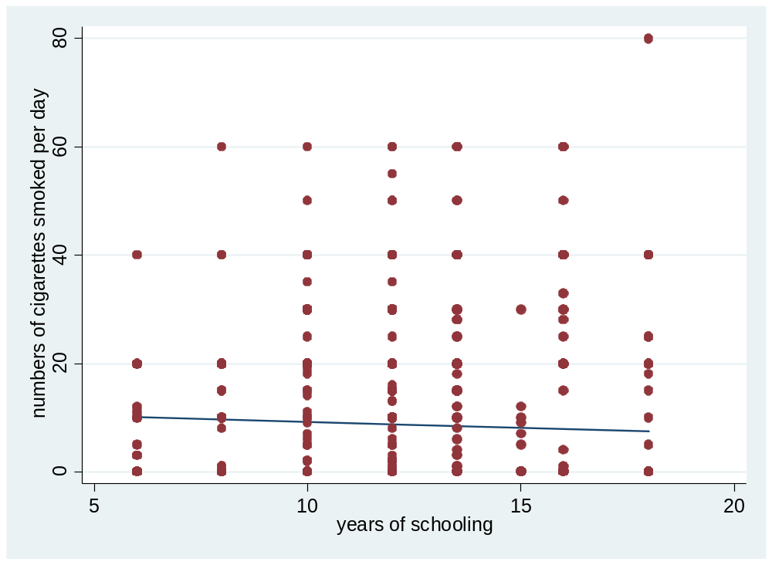
INTERPRETATION
v) how to delete constant?
d) i) The table below shows the regression results:
 | (1)
VARIABLES | Reg
educ | -0.452***
 | (0.162)
age | 0.826***
 | (0.154)
age2 | -0.00963***
 | (0.00168)
white | -0.624
 | (1.456)
restaurn | -2.796**
 | (1.104)
Constant | 0.669
 | (3.707)
Observations | 807
R-squared | 0.051
Standard errors in parentheses
*** p<0.01, ** p<0.05, * p<0.1

INTERPRETATION
ii)
iii) A)
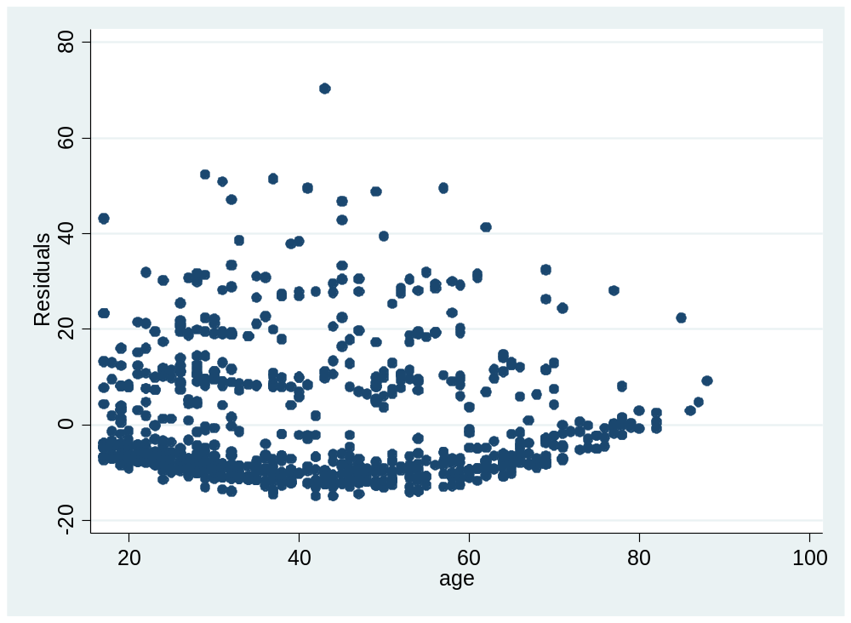
B)
C)
